IT 599: Master Capstone’s in Information Technology
Assignment 2: IT Project Implementation Plan
Unit 1: Database Upgrade Project
Professor Lynne Williams
Wilfredo Martinez
Kaplan University
July 24, 2017

Assignment 2: IT Project Implementation Plan
Project Overview
The sharing and reporting of data over the years have been synonymous with the organizational databases as long as the system to host them exit. System users now expect the sharing of information to be secure, efficient and immediate. The organization today handles a large amount of data and it becomes difficult for them to retrieve and manage. There is a need for organizations today to secure a single location for the storage of their data where they can easily access and utilize to improve on the business decisions, rather than where they traverse multiple databases. Use of a data warehouse can be of great assistance today. XYZ Company has been facing problems in managing its data due to its old database it's currently using in the business (Blavin, Ramos, Shah, & Devers, 2013).
The relational databases the company is currently using is not valid and does not satisfy the users' needs, thus the need to create a new system. The aim of the project is to modify their existing system both the hardware and software (Burke, 2013). The project will help solve some data handling and retrieval problems. Communicating the problem will have the following benefits to the company.
Scope
The system is aimed at creating a repository for the collected data in the enterprise. The data warehouse will be mainly used in data storage gathered from different areas. The new system will also be employed in the exploration of knowledge and ideas. Process re-engineering of the scheme will have to be done using the company standards enabling faster processing and parallelism thereby allowing users to access data easily. The users of the system will be the data handling team, and access will only be limited to authorized personnel.
Several customizations will be done based on certain levels and employee skills in data handling. Testing will be done on a monthly basis whereby unit testing is preferred to enhance the accuracy of stored data. Users of the system will be trained, and training will be done on those employees handling the data using the new regime (Morris, Peter, & Coronel, 2012).
Budget Estimation
The acquisition of software and the hardware aspects of the project will take approximately two weeks. The expenditure is expected to be the US $ 250,000 between the purchase to full implementation and installation. The team members will identify the required systems and report to the project manager who will make the order. Since most of the stations in the company have computers, the task will be easier than an overall technology adaptation projects. In the implementation phase, the project manager and the team will assess the preparedness of the team through trials involving a section of the employees. Adjustments to the original system will align the project to the company resources and available skills. The implementation of the project will take a total of twelve weeks at the expenditure of US $566,000.
Resources required
To successfully implement, the new system and attain the scope of the project, the management team must provide the following. First, they must provide some qualified staff who will be involved in the deployment of the system. Building a data warehouse is not a simple work since a lot of staff are included in the analysis, design and the implementation of the scheme. Resources are also required for the system to be implemented. Resources, in this case, are the hardware, software, and wages to pay the workers. Extra budget acting as the maintenance cost should allocate annually (Kerzner, 2004).
Stakeholders
The stake holders of the New Database/Data Warehouse System project shall include the private business enterprise sectors, the government business sectors, and non-profit making organizations
Stakeholders | Overview of the New Database Upgraded System (Info Warehouse) requirements | Names
Private business/industry sectors | Required an upgraded database software system that can support the business operations and client data records and administration at their local premises | Chief financiers
Government business associates | - Needed a database system that can keep track the records of returns on revenue taxed from public sectors  - Required system that can outline the database report on consequence of diseases on population  - Required system that can show the death rate, the growth rate, and mortality rate | Investors and share holders
Nonprofit making commercial sectors | - Required a system that can analyze organization logs and other business records stored at different sites to get placed on one individual site.  - Required a system that analyzes the trends of positioning or storing the transaction data | Support team
System Developers | Planning, analyzing, designing, implementing, testing, installation, and deployment, | Heads of modular programming
Project manager | Controlling and managing entire process of developing the database management and upgrade project | Project team leaders
Assistant project manager | Compiling deliverables | Employee name, business associates

Table1: Stakeholders table (VELICANU, 2007)
Project Benefits
The new database system upgraded supports the goals and objectives of the organization through the integrating the data and business operations within the centralized warehouse system The proposed database system shall improve the storage services as well as retrieving the data records for business operations in the most convenient manner according to employer’s needs. The entire system shall improve the processes involving the sharing of data and information through the implementation of the distributed database system from where our company and its business associates retrieve the records efficiently. The network shall get developed as viewed in the systems analysis process (Blavin, Ramos, Shah, & Devers, 2013).
Integrated data warehouse system with new database structure and centralized repository system is highly favored in the market due to its unique and business or user support services. The current business sectors require business or data systems to facilitate the accommodation of their customer and deliver satisfactory services to the company and the clients. The targeted sector is fast growing with the demand to offer swift and reliable services within a short duration of time. The implementation of the updated database system facilitates the quick communication procedures with the patients at any time locally and remotely. Thus facilitating easy accessibility, mobility and simplicity attribute required by the business system investors (VELICANU, 2007).
The new Data Warehouse Information System business operations through the implementation of the centralized database systems, and centralized clients' point of services. The centralized approach guarantees data and information consistency and eliminates redundancy. The distributed systems are implemented through the network approach that enhances the sharing of data and information among the departments in the corporate sector. The new Database Information System promotes the procedural models by automating primary operations outlined in line with the nature of the database services and appliances. Nowadays, using such system businesses provisioned with the easy and instant data retrieval at any instant or any place. Database recovery now an automated process such that database comprising of records of the clients and other business info gets automatically upgraded with the new database system following a centralized approach. The proposed system guarantees total compliance with the commercial sector processes and procedures and requirements thus providing the firm support to the business operations and appliances (Stanford, n.d.).
I strongly recommend the entire business sector to invest in the proposed project for it is viable within all scopes of operation. The project is most recent with the application of most modern database application methodologies and the implementation of the current trends in the economy. The functionality of the Database Information System guarantees a high level of scalability, availability, fault tolerance and user-friendly interfaces. The cost for the implementation is considered small with sufficient coverage of all required specifications and needs as stated in data collection session (Zeng, 2003).
Returns on Investment (ROI)
The reports generated from the calculations on the Return on investments (ROI) showed that the figures were above the standards set by the whole business sector. Database Management Information System had a Net Present value (NPV) acceptable by the industry sectors thus making the assimilation and adoption of the project viable. The Constructive Cost Model (COCOMO) methodology of project cost determination proved that the budget estimated was appropriate for the business sector to consider the project viable (Morris, Peter, & Coronel, 2012). On behalf of the execution of the proposal to usage similar plan in emerging the existing warehouse elucidation or “Database information management system” invented to decrease the manual or statistics errors in its supervision to demand the safety apprehension. The innovative project proposals the commendations for the association e.g. manufacturing industry or other IT related service to cope the vast quantity of statistics archives of the business records and customer data in a well-organized and safe mode. The plan will be implemented in a way to obtain the suggested technologies, tools, anticipated techniques as well as practices to achieve and scheme related arrangement of the program. The new upgraded database system development will employ the implementation as well as design tools equally per approvals and expenditures to reward these methodologies in the organization. Further in future, we will work on the upgrade of the developed database IS for the recognized stakeholders by incorporating additional purposes of enhancing the manual database administration process of the business institutions (Devlin, 1997).
Project Organizational Structure
The project comprises of different roles and accountabilities apart from project manager to build and implement such database management info system solution for the administration to keep easy track of the massive database at one site on the single database system. The administrative arrangement of the venture involves various roles and responsibilities like Project Head or Manager, business analyst, system analyst, database administrator, web developer/designer, testing team, etc. The full administration roles and responsibilities are presented in the form of project organization chart of our database upgrade system project shown below as:
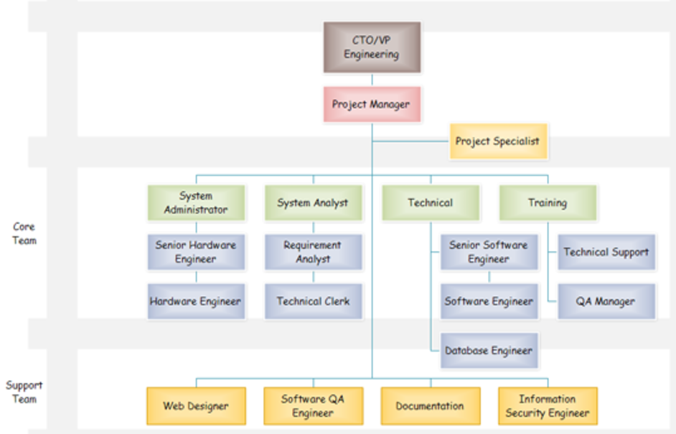
Figure 1: Project Organizational Structure
Project members’ roles and responsibilities (Project Organization Structure)
Roles | Responsibilities
Project Sponsor/head | System Initiation Sign-off and Budgetary regulations (concerns) sponsor whole project investment and actions
Project Manager | Administer project operations and accomplishes planning to implementation activities of the project
System Analyst | Analyst offers with accountabilities of project requirement analysis, planning, scope definition, etc.
Business Analyst | Performs the economic and business analysis of the project.
Database Administrator | Manages the database operations like update, retrieval, modification, and database migration functions.
Solution Architect | The role comprises of design, building, coding, testing, and maintenance of the HIS application.
Technical Development Lead | This team looks for the major implementation and application development tasks.
Testing Lead | Testing his request code and modules.

Work Breakdown Structure with Gantt chart
The Gantt chart with tabular form WBS of the “Upgraded Database Info Management System” project is mentioned with included tasks, durations, dependencies, predecessors, milestones, and resources in MS Project (.mpp) file attached to the unit 2 assignment. The Gantt chart with WBS of the project is given below made in MS Project Professional 2013 version tool (Kerzner, 2004).

Project Plan (including planned, scheduled tasks/activities)
Practically each of the business associations had rigorous, long-lasting scheduling and expansion stages that convoluted “New Upgraded Database System customization,” maintenance procedure restructure to provision usage of the “Database Management Info System (Warehouse Management System,” in addition to end-user preparation of the system usage. The “design, build, validate” stage acquired one year or (extra frequently) lengthier, resultant to a stunning introduction to diverse data administration practices crosswise an IT framework, commonly through a “big bang” execution (each division at one time) inside any single corporation. Such form of “big bang” performance is frequently compulsory since of the inter-connectedness of every groups and framework inside our association. An even particular business organization, which revolved out database upgrade purposes in a couple of phases, highlighted the prerequisite to executing new functions cross ways all components in a competence at the similar stage (Inmon, 2005). Simply two IT frontrunners preferred a phased methodology that permits for documentation of complications beforehand complete execution. The development and planning period diverse amid hospitals and frameworks, however, the specific interval from the choice to acquisition the EHR to execution was around “two to three years.” The project plan for our project appraisals for the “start and end date of each activity” besides the “level of effort” compulsory in every undertaking. For the research project on the implementation of the upgraded database management system in the association as a client, we followed the qualified project plan given below in the document (Berson, 2004).
The project plan for our project appraisals for the “start and end date of each activity” besides the “level of effort” compulsory in every undertaking. For the research project on the implementation of the upgraded database management info system in the association as a client, we followed the qualified project plan given below as:
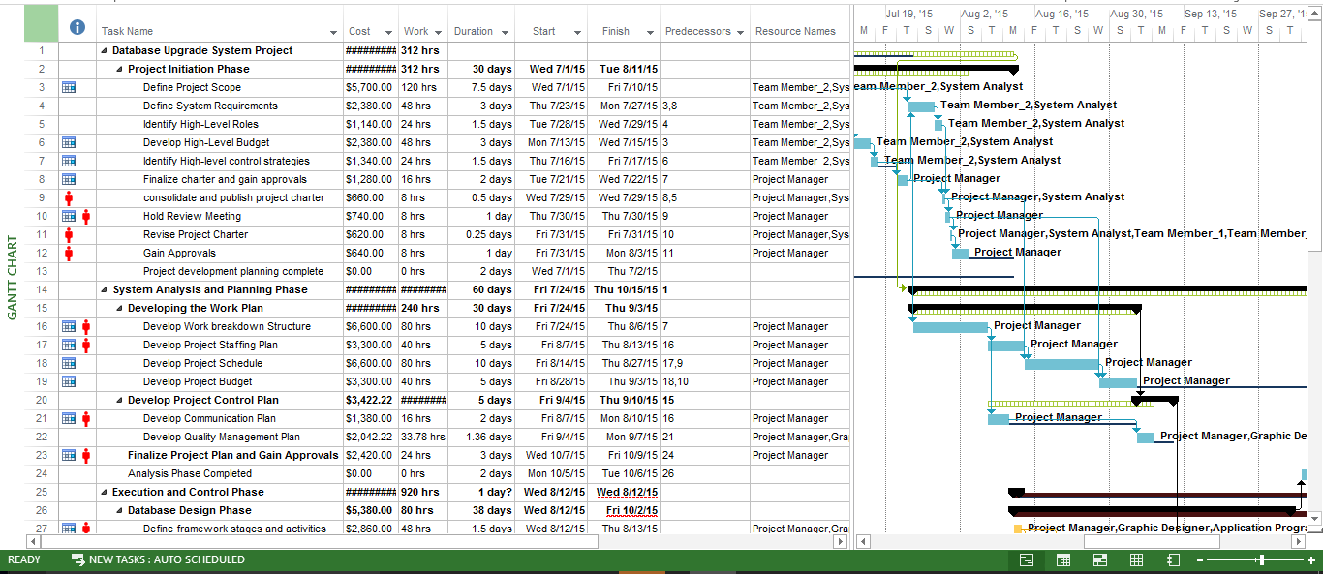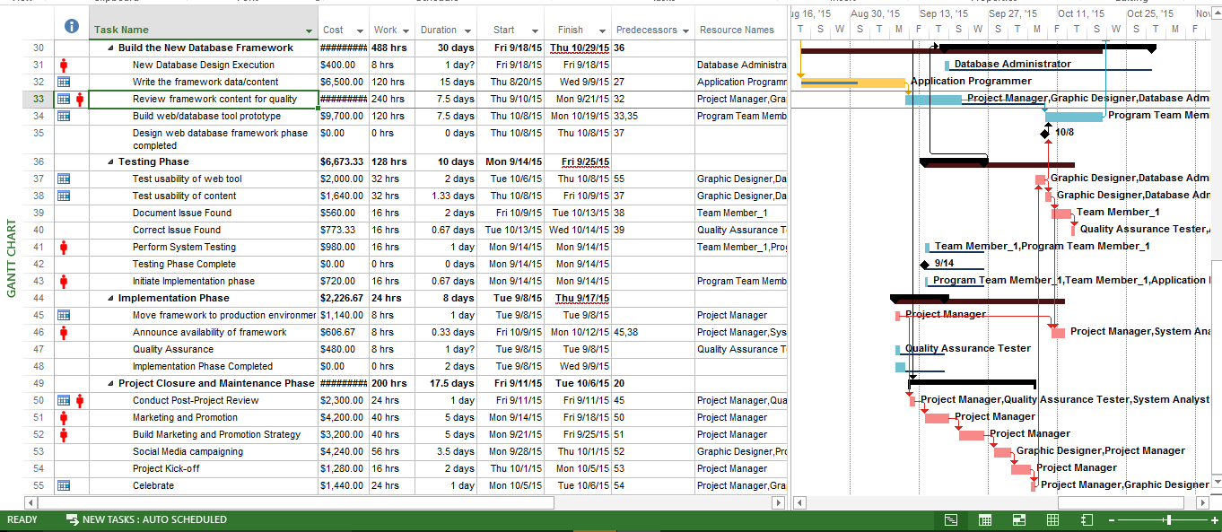
Figure 2: Gantt Chart View with WBS

People or Staff Resources
There are several possessions or resources in the arrangement of workforce persons that are subsidized in the accomplishment of the Upgraded Database information system development project, for instance, Project Supervisor, database administrator, business sponsor, project advisor, web developer, labor team, network administrator, web designer, core, and management team, IT expert, support team, core analysis squad and others. We are made a request to designate the assessed or speculated expenses to each of these individuals’ resources in the venture improvement (in dollars) frame. We relegated them as indicated by the standard charges every hour of the working in the enterprise. With each errand consolidating these individuals’ assets are apportioned with the dollars as the standard rates of business. These work and other venture expenses are appointed by the quantity of aggregate hours the property are working and utilized as a part of the research project plan.
“Table 1. Costs and resources of the project tasks.”
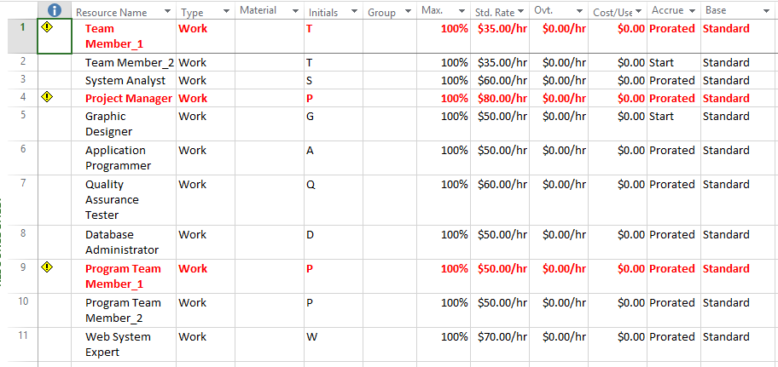
Critical Path with Milestones
The Project comprises of certain (2-4) critical paths that comprise of major milestones in the schedule of the project. These are given in the (.mpp) MS Project file attached. The critical path is also demonstrated in the form of red color bars shown in the Gantt display area of the chart made in MS Project in the WBS and Gantt Chart section of the paper in the previous segment.
Risk Management Plan
Risk analysis
There are various risks involved during the project development like program module’s implementation, cost estimation, budget requirements, problems, etc. The risks included the slowing of the project development. The risks and changes in the system or the project is on the organizational level, which has developed it and the change management involves the different strategies to implement and manage the project change. The risks embraced in database upgrade project to administer the client records identified from security issues to the financial risks.
Project Risk assessment matrix
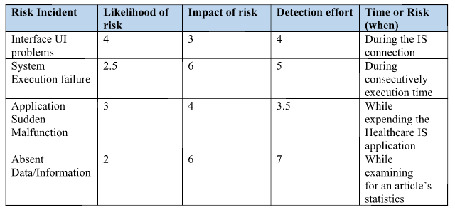
Risk Severity Matrix
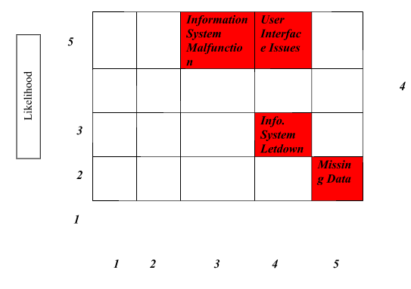

The new regime is however associated with some serious risks to the organization. The first major risk is security risks. The data in the data warehouse if not properly stored may be accessed by malicious and unauthorized individuals who may steal the information for malicious activities. If the project is poorly designed, the systems may collapse leading to data loss. The other risk is the risk associated with a significant amount of data. A large amount of data may slow down the system performance leading to inefficiency. Lack of proper experience and skill among the development team is another risk to this project. Some developers may not understand the organizational need and integration of the data warehouse, and therefore they end up building the wrong thing.
The human labor resources required include the database developers for implementing database design and coding. The system programs are needed to perform the various business functionalities. The project portfolio managers have an obligation to manage and control the project development process. The experts required during the different stages of development shall be employed under contract as well as through binding for the most technical applications within the process of development. The developing team shall acquire training from the experts during and after the session with experts.
The contractual hardware requirements tools include the use of the following utilities in the network
- The database server version 5.0 or above
- The computer workstations with hard disk drive of 1 terabyte and above
- The processing power of the workstations should be above 3.4 Gigahertz
The contractual software requirements tools include the use of the following
- Windows server operating system version 2008 or above
- Windows 8 or above for the workstation operating system
- The kernel drivers that support graphics with open gel files (Ma C., 2000)

References
Berson. (2004). Data Warehousing, Data Mining, & Olap. Tata McGraw-Hill Education.
Blavin, F., Ramos, C., Shah, A., & Devers, K. (2013, August 01). Final Report: Lessons from the Literature on Electronic Health Record Implementation. Retrieved from healthit: https://www.healthit.gov/sites/default/files/hit_lessons_learned_lit_review_final_08-01-2013.pdf
Devlin, B. (1997). Data Warehouse: From Architecture to Implementation. Addison-Wesley.
Inmon, W. H. (2005). Building the Data Warehouse. Wiley & Sons.
Kerzner, H. (2004). Advanced Project Management: Best Practices on Implementation. John Wiley & Sons.
Ma C. (2000). Data Warehousing, Technology Assessment, and Management. Industrial Management and Data Systems, 125-135.
Morris, S., P. R., & Coronel, C. (2012). Database Systems: Design, Implementation, and Management. Cengage Learning.
stanford. (n.d.). Data Warehousing. Retrieved from stanford: http://www.db.stanford.edu/warehousing
VELICANU, M. (2007). Building a Data Warehouse step by step. Informatica Economica, 83-89. Retrieved from http://revistaie.ase.ro/content/42/velicanu.pdf
Zeng, Y. (2003). Enterprise Integration with Advanced Information Technologies: ERP and Data Warehousing. Information Management and Computer Security.

